Assignment 5 QiJun Hou

Conclusion: I performed several experiments to test that the depth/height of a Binary Search Tree after 10/100/1000 (Hibbard) deletions and insertions .And based on the chart I draw a conclusion that with the increasing of insertion and deletion. The depth of the binary tree will be proportional to the square root of N where N is the size of the tree. It is not hard to find that the c=1000 line is the closest to the size N line from the chart

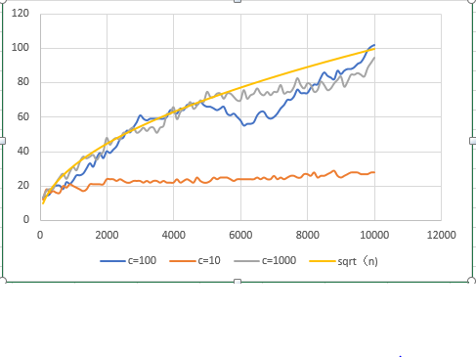

The unit test past screenshot: